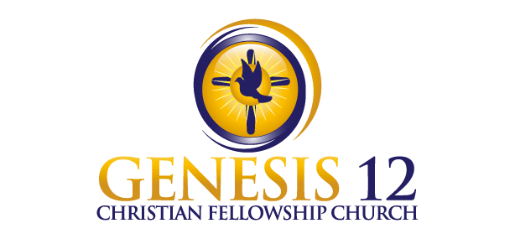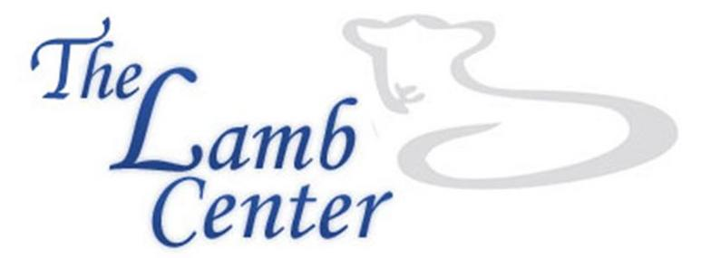
genesis12church.org thelambcenter.org

In an effort to better support one of our community partners, The Lamb Center,
Genesis 12 Christian Fellowship Church will hold monthly donation drives to collect items on The Lamb Center’s most urgent needs list.

The Lamb Center is an organization whose mission is to serve the poor and homeless, transform lives, and share God’s love. It is a day center for the homeless located in Fairfax that provides services such as hot meals, hot showers, clean laundry, haircuts, resume assistance, mail service, Bible study, counseling, and so much more!

You can help by donating goods that help defray the costs associated with managing the program.

MONTH | DONATIONS BEING COLLECTED
JANUARY 2018 | MLK Day of Service Drive – January 115
FEBRUARY 2018 | New thermal underwear and/or new socks for men and women
MARCH 2018 | Trash bags – 55-gallon and/or 13-gallon with drawstring
APRIL 2018 | Shaving cream and/or razors
MAY 2018 | Toothbrushes
JUNE 2018 | Smart Trip Metro Cards ($10 – card costs $2 and $8 is stored on it for trips)  Smart Trip cards may be purchased online at wmata.com or at CVS and Giant stores or at any Metro Rail station
JULY 2018 | Styrofoam dinner plates, Styrofoam coffee cups (8 oz), Styrofoam bowls, plastic utensils
AUGUST 2018 | Small deodorant/anti-perspirant
SEPTEMBER 2018 | Lysol spray
OCTOBER 2018 | Laundry detergent, bleach
NOVEMBER 2018 | Coffee, instant oatmeal, Poptart,  Gift cards – Walmart, Costco, BJs

Drop donations off, at any time during the month, in the Lamb Center donations bin located in the basement of the Little White Church.

Want to work in our ministry to the Lamb Center? Here’s how you can help today:
- Delivery – Volunteer to pick up items from the Little White Church and deliver them to The Lamb Center, 3160 Campbell Drive, Fairfax, VA 22031.

